SMART LIBRARY

Submitted By

Most. Sumaiya Akter Sithi

ID:0242220005101915
Dept. of CSE, DIU

MINI LAB PROJECT REPORT
This Report Presented in Partial Fulfillment of the course CSE416: Web
Engineering Lab in the Computer Science and Engineering Department



DAFFODIL INTERNATIONAL UNIVERSITY
Dhaka, Bangladesh
November 4, 2025

DECLARATION
We hereby declare that this lab project has been done by us under the supervision of Md Jahangir Alam, lecturer, Department of Computer Science and Engineering, Daffodil International University. We also declare that neither this project nor any part of this project has been submitted elsewhere as lab projects.

Submitted To:

Md. Jahangir Alam
Designation: Lecturer
Department of Computer Science and Engineering,
Daffodil International University

Submitted by

Most. Sumaiya Akter Sithi

ID:0242220005101915
Dept. of CSE, DIU

COURSE & PROGRAM OUTCOME

The following course have course outcomes as following:.

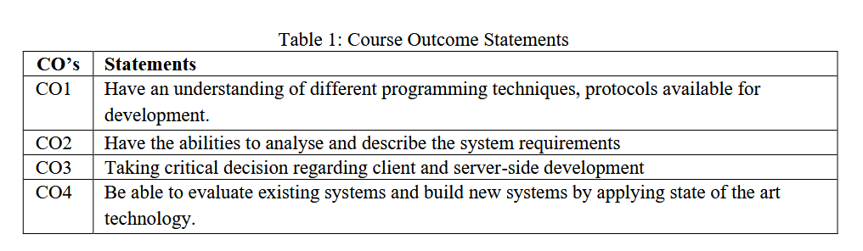

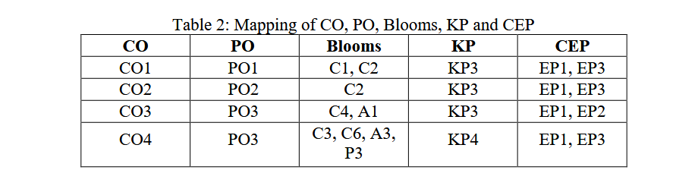

The mapping justification of this table is provided in section 4.3.1, 4.3.2 and 4.3.3.

Table of Contents

Declaration i

Course & Program Outcome ii
- Introduction 1
  - Introduction 1
  - Motivation 1
  - Objectives 1
  - Feasibility Study 2
  - Gap Analysis 2
  - Project Outcome 2
- Proposed Methodology/Architecture 3
  - Requirement Analysis & Design Specification 3
    - Overview 3
    - Proposed Methodology/ System Design 3-
    - UI Design 4
  - Overall Project Plan 8
- Implementation and Results 9
  - Implementation 9
  - Performance Analysis 9
  - Results and Discussion 9
- Engineering Standards and Mapping 11
  - Impact on Society, Environment and Sustainability 11
    - Impact on Life 11
    - Impact on Society & Environment 11
    - Ethical Aspects 11
    - Sustainability Plan 11
  - Project Management and Team Work 11
  - Complex Engineering Problem 11
    - Mapping of Program Outcome 12
    - Complex Problem Solving 12
    - Engineering Activities 13

Table of Contents Table of Contents

- Conclusion 14
  - Summary 14
  - Limitation 14
  - Future Work 14
References 15

Chapter 1

Introduction
This chapter provides an overview of the background, purpose, workflow, and expected outcomes of the Smart Library project.

Introduction
Library systems have always played a central role in supporting learning, reading, and research activities. However, traditional libraries often require manual search, physical presence, and dependency on librarians to locate or manage books. As modern users prefer quick access and digital convenience, there is a growing need for a simple and interactive system that allows users to browse, filter, and manage books easily.
The Smart Library project addresses this problem by providing a browser-based digital platform where users can log in, view available books, add items to favourites or cart, and perform actions such as renting or buying books through a user-friendly interface. The system aims to simplify library interactions and make book discovery faster and more enjoyable.

Motivation
The main motivation behind developing the Smart Library is the increasing demand for digital access to resources. Students, casual readers, and new learners often struggle to find a convenient way to track and organize the books they like without physically visiting a library. This project provides an opportunity to build a fully functional mini–library system using simple front-end technologies, which helps in improving programming skills and understanding UI/UX concepts.
Additionally, creating such a system is personally beneficial, as it demonstrates the practical use of HTML, CSS, and JavaScript in building real-world applications. The project also helps in strengthening problem-solving ability and preparing for more advanced web development work in the future.

Objectives
The primary objective of the Smart Library project is to design and implement a user-friendly digital library interface. The specific objectives are:
- To provide a clean and interactive platform for users to browse a collection of books.
- To implement features such as login, favourites, cart, search, sorting, filtering, and pagination.
- To create an accessible system that allows users to rent or buy books with confirmation prompts.
- To maintain user-specific data such as login status, favourites, and cart items using LocalStorage.
- To ensure smooth usability across different screens with visually appealing design and dark mode support.
- To simulate essential functions of a digital library using only client-side technologies.

Feasibility Study
Several existing digital library systems and book management applications inspired the development of this project. Many modern platforms like Google Books, Goodreads, Kindle Library, and various university e-libraries allow users to search and organize books digitally. Although such systems offer advanced features, they are often complex and require backend integration.
The Smart Library adopts a simpler approach by replicating core functionalities using only front-end techniques. The system is technically feasible because HTML, CSS, and JavaScript are widely supported and require no additional cost or server setup. Economically, the project is free to develop, and operationally, it is easy to use as it runs directly in a web browser.
Methodologically, the project follows a lightweight design inspired by modern web applications, ensuring a practical learning experience without the need for complex infrastructure [1].

Gap Analysis
Although many digital libraries exist, most of them depend on backend servers, databases, and complex authentication systems. Beginners often struggle to understand how such systems work. There is a gap for a simple, easy-to-learn digital library interface that provides real-world functionalities but remains fully client-side.
The Smart Library fills this gap by offering essential library features—such as user login, managing favourites, adding to cart, searching, filtering, and renting/buying books—without relying on server-side processing. This makes the system ideal for learning, academic use, and small-scale digital library demonstrations.

Project Outcome
The Smart Library project successfully produces a functional digital library platform that is visually attractive, responsive, and easy to use. Users can log in, explore books, manage favourites and cart items, and interact with the system through several useful features. The system demonstrates how a complete mini-library can be built using only front-end technologies.
The outcome also includes improvement in the developer’s understanding of interface design, event handling, browser storage, and interactive web development. Overall, the project results in a practical, educational, and effective digital library system that can be expanded in future versions.
The final Smart Library system successfully provides:
- A clean interface
- Effective book browsing
- User-friendly interactivity
- Smooth feature execution
- A complete front-end library management experience

Chapter 2

Proposed Methodology/Architecture

This chapter explains the requirement analysis, design approach, system architecture, and UI planning for the project.

Requirement Analysis & Design Specification

Overview
The Smart Library is a browser-based digital library system that allows users to conveniently browse, search, and manage books online. The application is fully built using HTML, CSS, and JavaScript, and all book information is stored as JavaScript objects, which makes the system fast and easy to use without any server. After logging in, users can access features such as searching, category filtering, sorting, pagination, favourites, cart, and rent/buy options. User preferences like favourites and cart items are saved using LocalStorage so they remain available even after refreshing the page. With a clean UI, responsive grid layout, overlays for favourites and cart, and a dark mode option, the system provides a simple and user-friendly digital library experience.

Proposed Methodology/ System Design
System Workflow:
- User opens homepage
- User logs in
- Controls (search, filter, sort) become active
- Books load with pagination
- User can favourite, add to cart, rent, or buy
- Favourites and Cart open in overlay windows
- User logs out
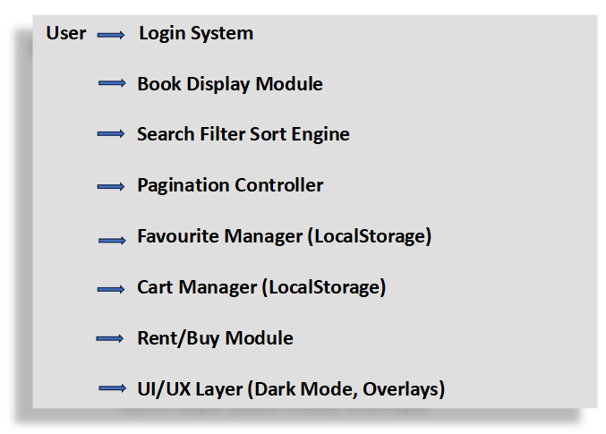

UI Design
Key UI Components:

Header section with navigation buttons

Login popup

Search/filter/sort controls

Book cards (image, title, category, price, fav, cart, rent, buy)

Overlays for favourites and cart

Dark/light mode switch

Responsive grid layout

The UI follows a modern glassmorphism style with shadows and hover animations.

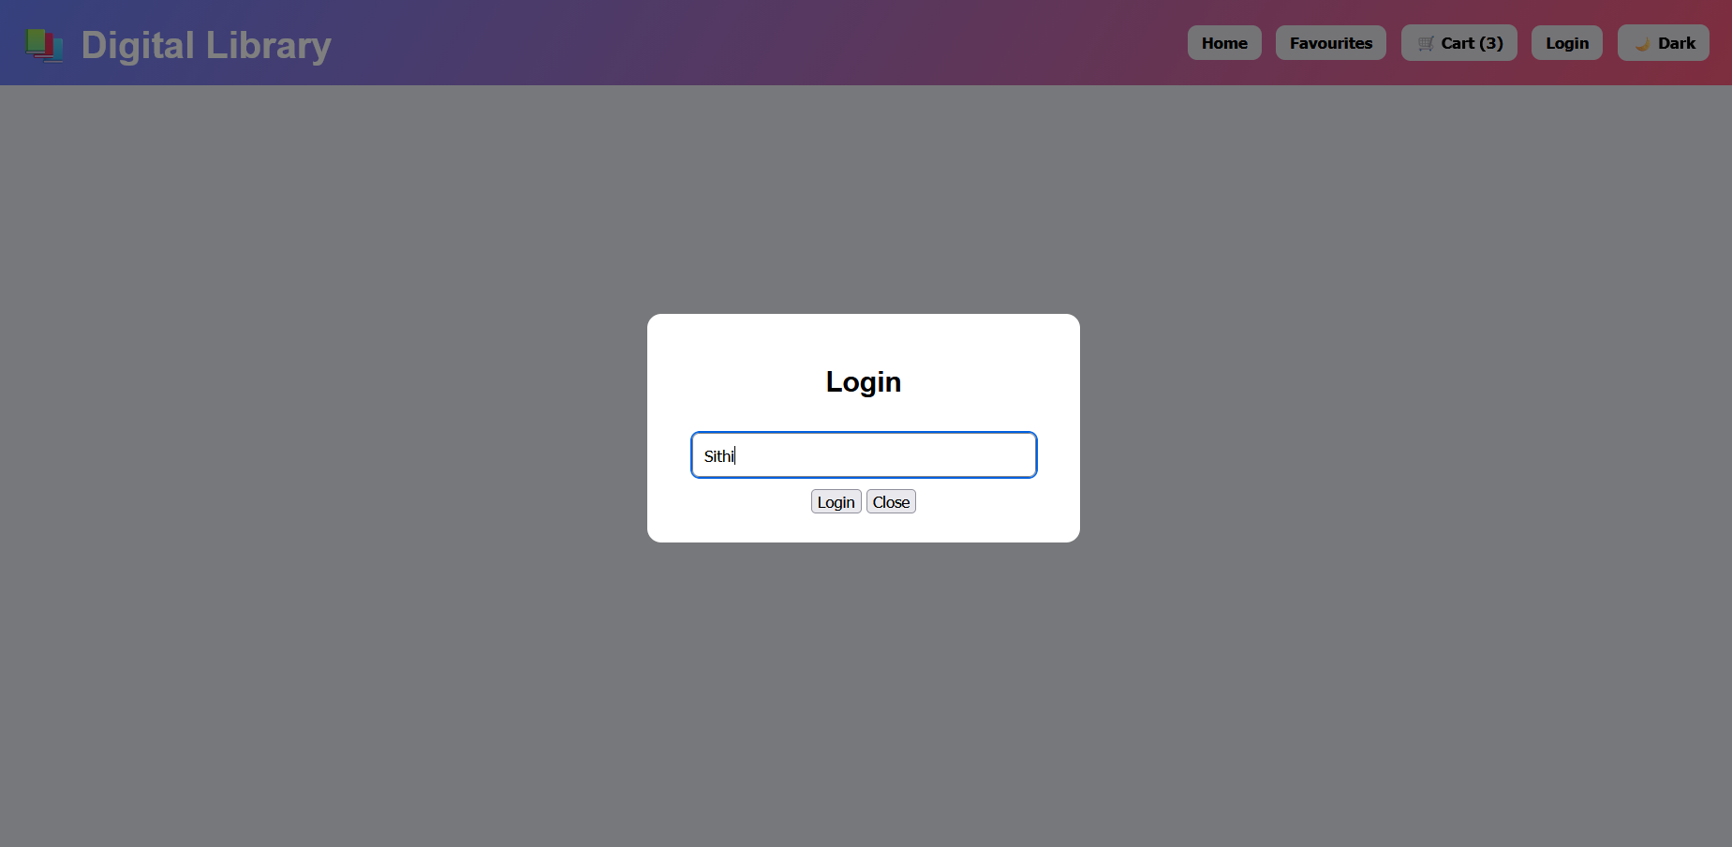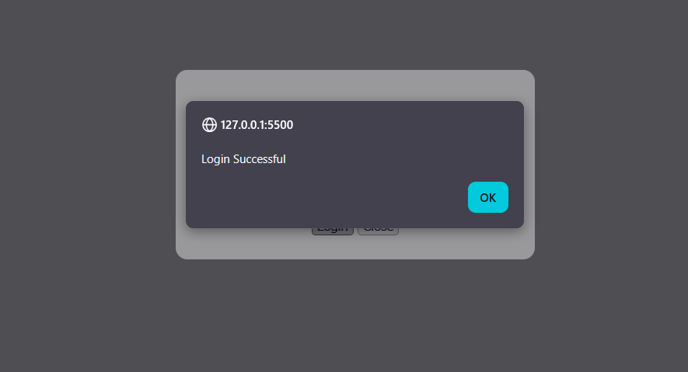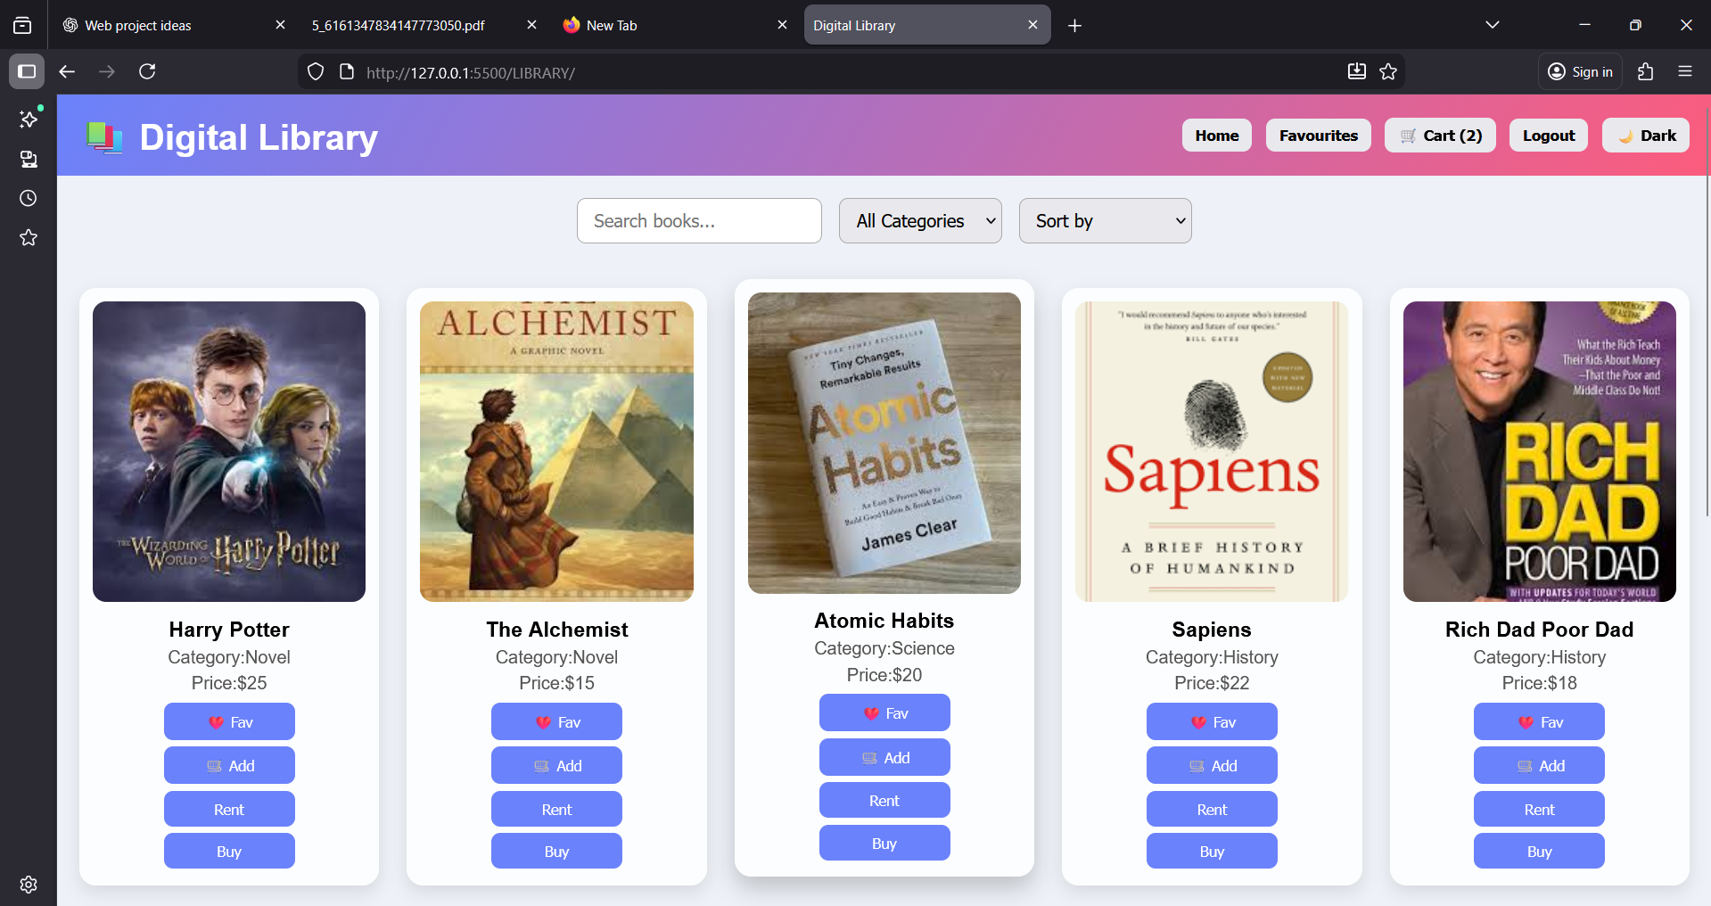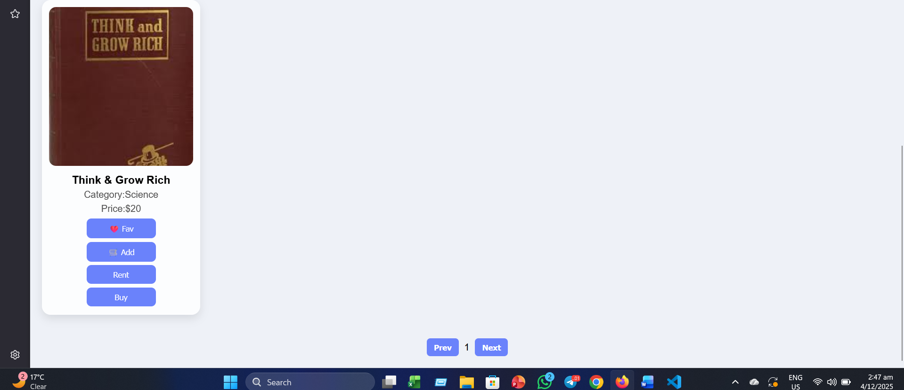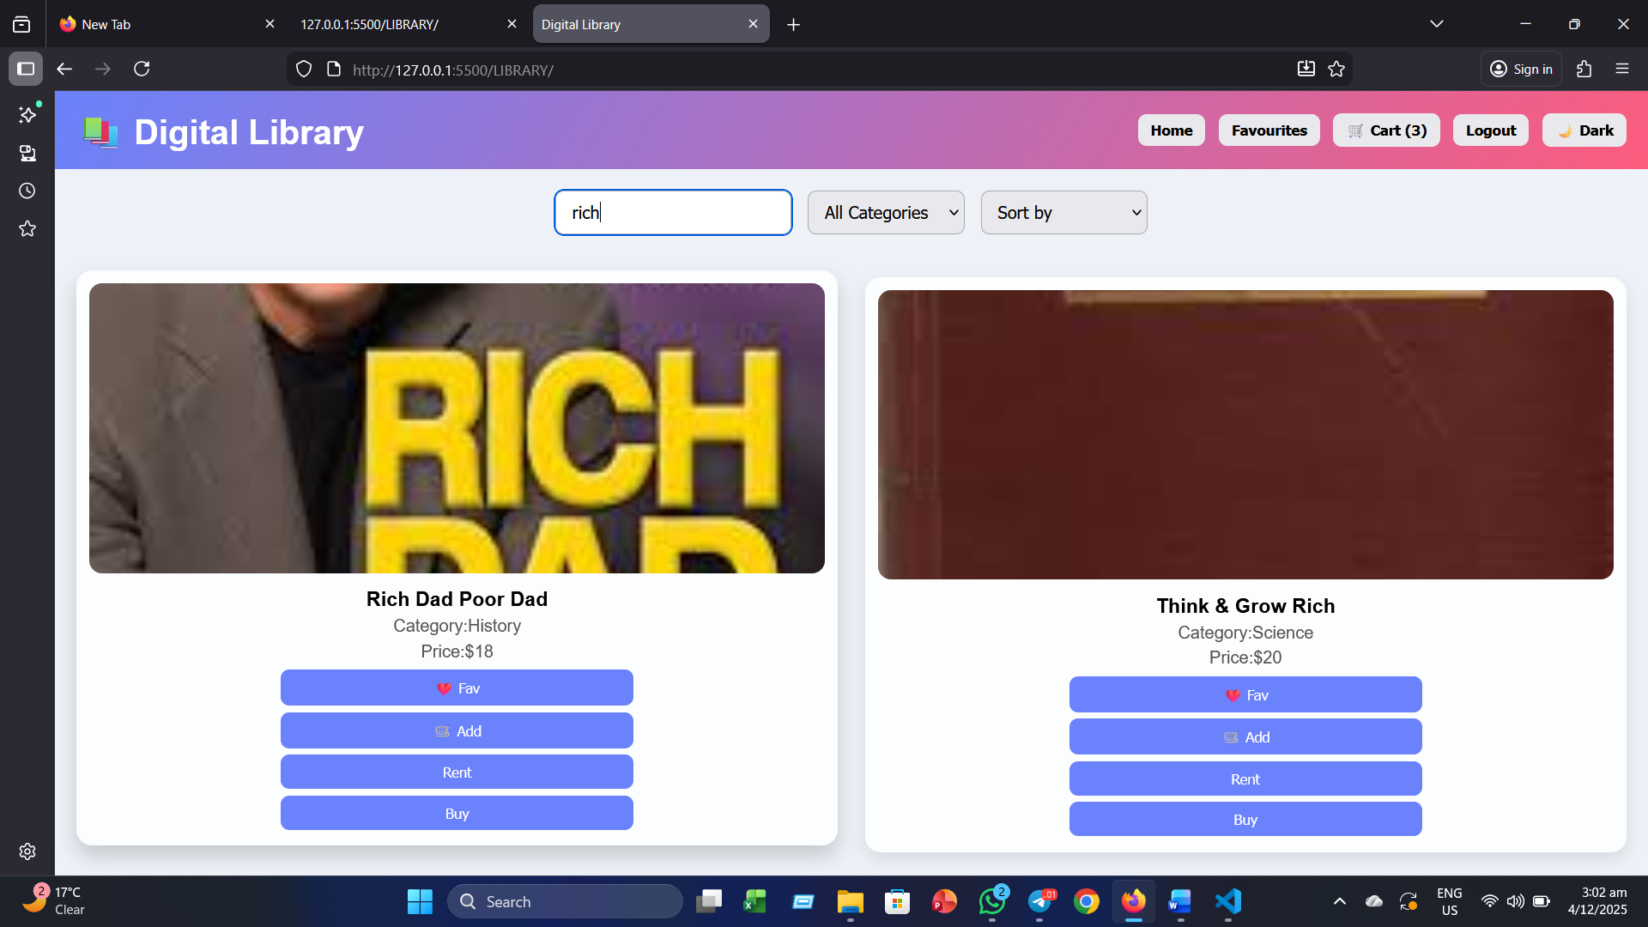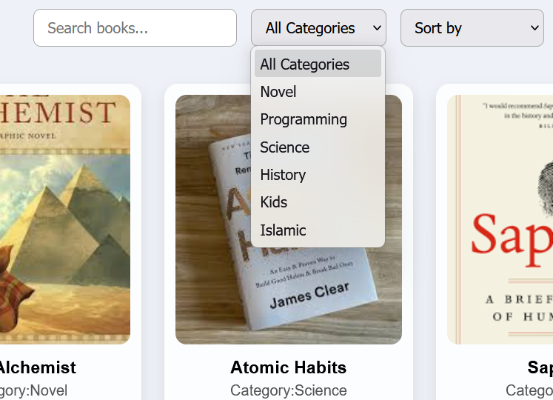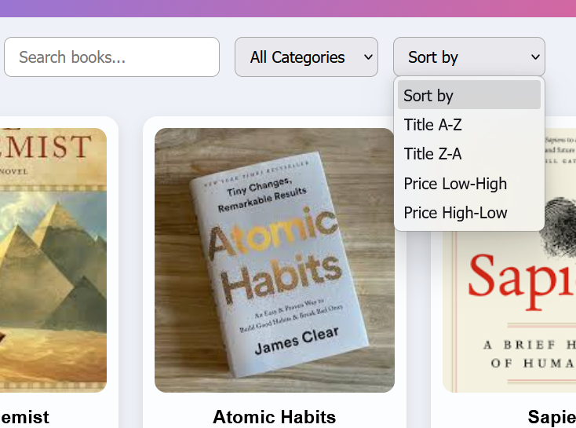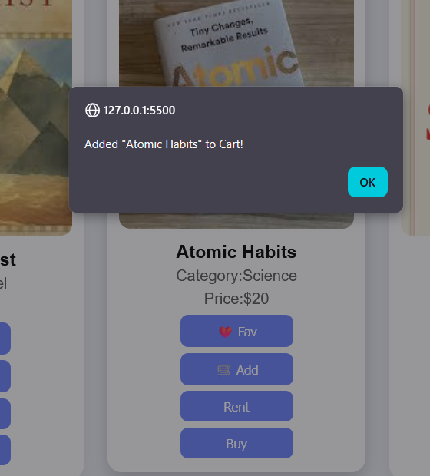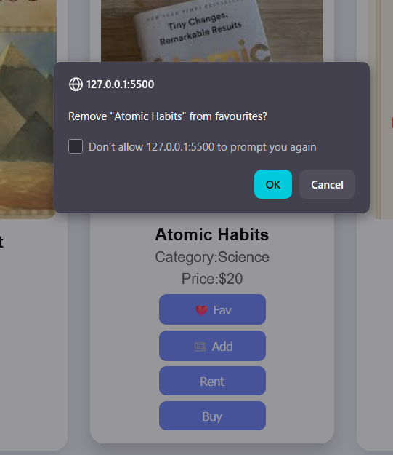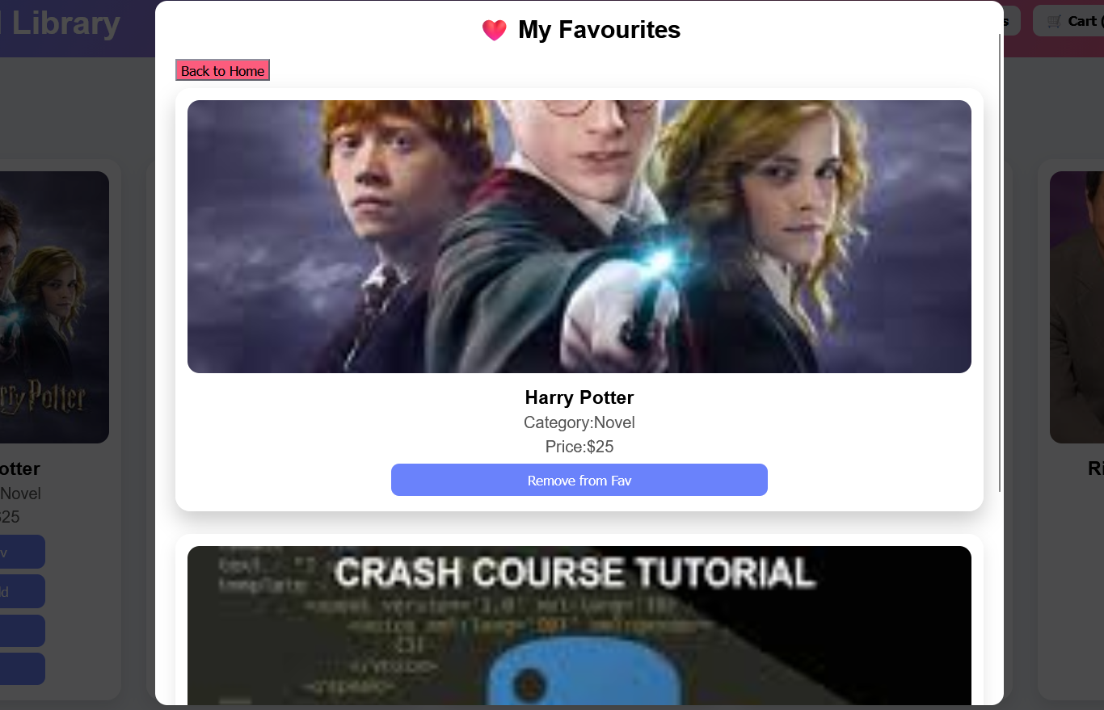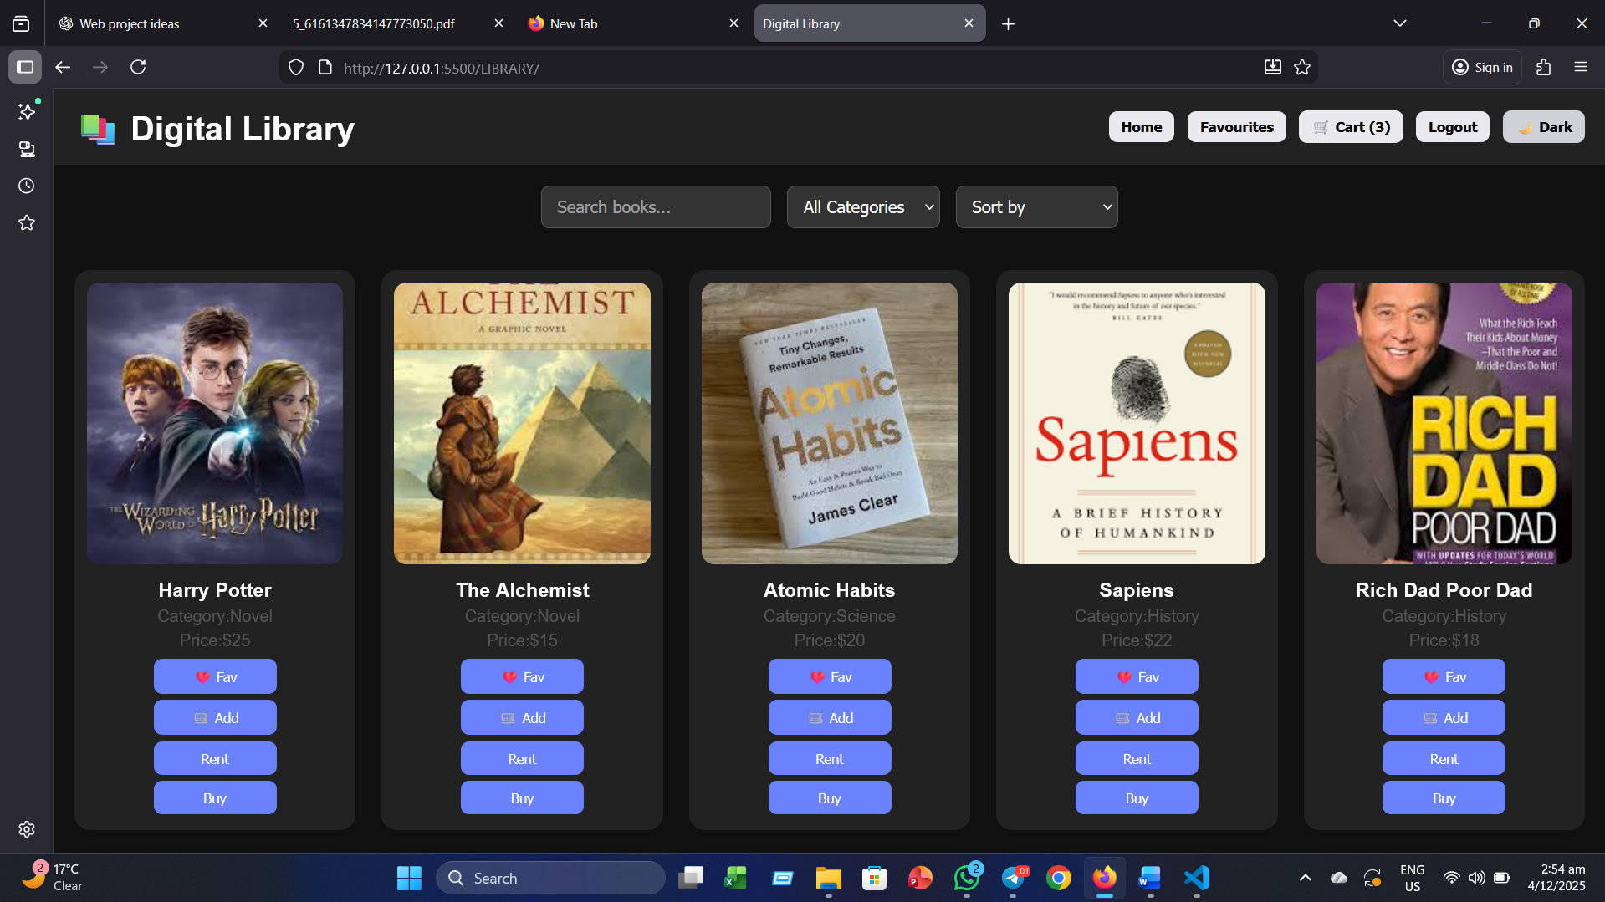

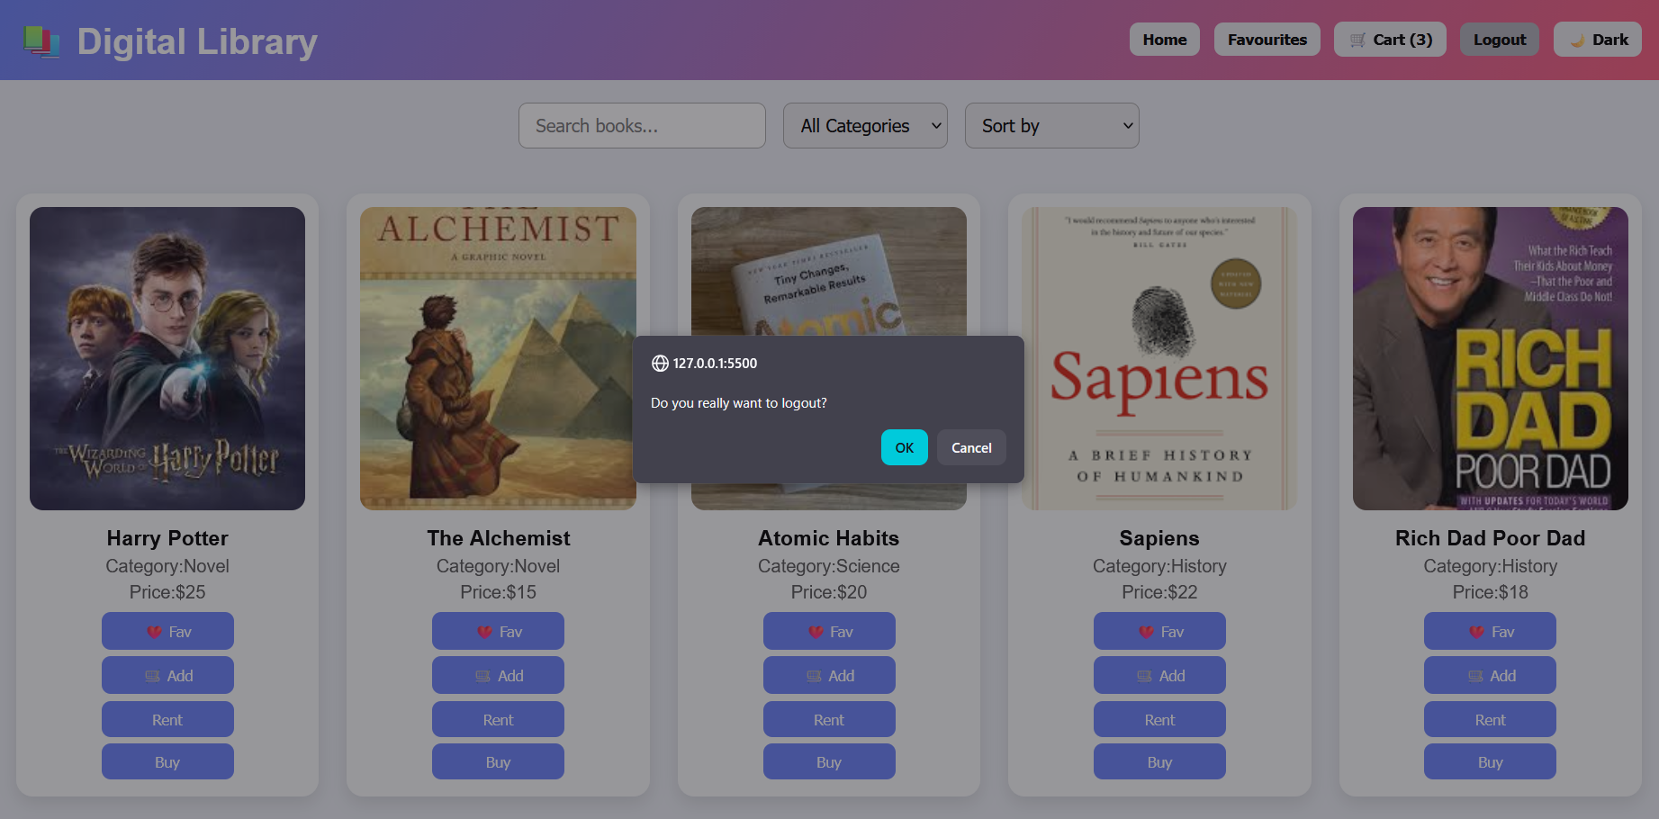

Overall Project Plan
The overall plan of the Smart Library project started with identifying the necessary features such as book browsing, search, filter, sort, login, favourites, cart, and user interactions. After finalizing the requirements, the structure of the interface was designed, including the layout of the header, controls, book cards, overlays, and login popup. The next step focused on implementing the UI using HTML and CSS, followed by adding full functionality through JavaScript for dynamic book loading, LocalStorage-based data handling, and event-driven interactions. Once all features were integrated, the system was tested to ensure that searching, filtering, pagination, favourites, and cart operations worked smoothly. Finally, visual refinements and dark mode were added to enhance user experience, and the complete project was reviewed and documented.

Chapter 3

Implementation and Results

This chapter describes how the system was implemented and presents the final output

Implementation
The project was implemented using:

HTML Structure

CSS Responsive UI + Dark Mode

JavaScript Functional engine

Important implementation components:

LocalStorage-based user management

Dynamic book rendering using DOM

Search, filter, sort algorithms

Pagination using page slicing

Favourite/Cart overlays

Rent/Buy confirmation dialogs

Dark mode toggling

Interactive book cards with hover effects

Performance Analysis
The Fast loading: All data is stored locally.

Low memory usage: Only 13 book objects.

UI responsiveness: Grid layout adjusts to mobile/tablet/desktop.

Instant search/filter: Uses JavaScript array operations.

LocalStorage performance: O(1) access time.

Result: The system performs smoothly with no noticeable delays.

Results and Discussion
The Smart Library project successfully delivered a fully interactive digital library system where users can browse books, manage favourites, and maintain a personalized cart. The interface is clean, modern, and easy to navigate, supported by a functional login system and smooth browsing features such as search, filtering, sorting, and pagination. User data is stored through LocalStorage, which ensures that favourites and cart items remain saved even after the page is refreshed. During testing, users found the UI attractive and simple to use, and features like pagination helped them easily navigate larger book lists. The dark mode option further enhanced readability and comfort, especially in low-light environments. Overall, the system performed smoothly, met all core objectives, and demonstrated strong potential for future extension through backend integration and database support.

Chapter 4

Engineering Standards and Mapping

This chapter focuses on the societal, ethical, environmental, and sustainability aspects of the project.Impact on Society, Environment and Sustainability

Impact on Life
The Smart Library system improves accessibility to books, helping students and general users find, organize, and manage reading materials easily. It supports self-learning, reduces time spent searching for physical books, and encourages efficient digital reading habits.

Impact on Society & Environment
By shifting from physical libraries to a digital platform, paper usage and printing needs are reduced significantly. This contributes to environmental sustainability and lowers carbon footprint. Society benefits from easier access to educational resources regardless of geographical limitations.

Ethical Aspects
The system maintains ethical considerations by storing only minimal user data (username) and not collecting any sensitive information. All actions are transparent, and no harmful content or misuse of user information takes place. Users have complete control over their saved data.

Sustainability Plan
The project is scalable and sustainable because it uses lightweight technologies (HTML, CSS, JS). It can be expanded in the future by adding backend APIs, databases, cloud storage, admin dashboards, and role-based access. The system’s modular structure ensures long-term maintainability.

Project Management and Team Work
The project followed a structured approach where tasks such as requirement analysis, UI design, JavaScript functionality, LocalStorage handling, testing, and documentation were divided among team members. Collaboration tools and regular discussions helped maintain consistency.
Cost Analysis:
Since this is a client-side web application, no major financial cost is required. Development tools (VS Code, browser) are free.
- Primary Budget: 0 BDT (no hosting, no backend)
- Alternate Budget (with deployment):
  - Domain: 900–1200 BDT/year
  - Hosting: 1000–1500 BDT/year
Rationale: If published online, domain and hosting would enable public access and real-world usage.

Complex Engineering Problem
This section explains how the Smart Library system meets the required Program Outcomes (PO), Complex Problem Solving categories (EP), and Engineering Activities (EA).categories.

Mapping of Program Outcome
Table 4.1: Justification of Program Outcomes
PO | Justification
PO1 | The project aligns with PO1 as it demonstrates understanding of programming techniques and protocols by using HTML, CSS, JavaScript, LocalStorage, event-handling, DOM manipulation, and UI/UX principles. These reflect CO1 (knowledge of development techniques).
PO2 | The system analyzes user requirements such as search, filter, login, favourites, and cart. This relates to CO2, where the ability to analyze and describe system requirements is demonstrated through feature planning and functional implementation.
PO3 | The project supports critical decision-making in client-side development (CO3) and demonstrates system evaluation and improvement (CO4). Implementing pagination, dark mode, overlays, and persistent data storage shows application of modern technology and engineering judgment.

Complex Problem Solving
Table 4.2: Mapping with complex problem solving.
EP | Description / Rationale Based on Project
EP1 – Depth of Knowledge | The project required understanding of web development concepts, DOM manipulation, persistent storage (LocalStorage), UI rendering, and event-driven JS. (Linked to CO1, CO2, CO3, CO4; KP3/KP4)
EP2 – Range of Conflicting Requirements | Balancing usability, performance, and simplicity—such as maintaining fast search/filtering while ensuring clear UI layout—reflects conflicting requirements that needed resolution.
EP3 – Depth of Analysis Required | Implementing sorting, filtering, and pagination required analyzing data structure behavior and choosing efficient logic suitable for a browser-based environment.
EP4 – Familiarity of Issues | Common web issues like responsive layout, clutter management, and UI lag were recognized early and handled with proper design choices and modular JS functions.
EP5 – Extent of Applicable Codes | Development followed standard HTML semantics, CSS structuring, and JavaScript best practices, consistent with industry coding standards.
EP6 – Extent of Stakeholder Involvement | Stakeholder expectations (students wanting a simple and accessible library system) shaped the feature set: search, filter, favourites, cart, and dark mode.
EP7 – Interdependence | System components (login module, display engine, LocalStorage, overlays, UI controls) depend on each other. The interaction of these modules represents interdependent engineering activities.

Engineering Activities

Table 4.3: Mapping with complex engineering activities.
EA | Description / Rationale Based on Project
EA1 – Range of Resources | The project used various engineering resources such as HTML for structure, CSS for UI styling, JavaScript for logic, DOM APIs for rendering, LocalStorage for persistence, and browser developer tools for testing. These represent a wide range of modern software development resources.
EA2 – Level of Interaction | Multiple system components interact—login module communicates with LocalStorage, search/filter interacts with the book dataset, overlays interact with UI rendering, and pagination interacts with display logic. This shows a high level of interaction between sub-systems.
EA3 – Innovation | Features like dark mode, glass-effect UI cards, dynamic overlays for favourites and cart, and persistent cart/favourite functionality using LocalStorage demonstrate innovation beyond a basic digital library system.
EA4 – Consequences for Society and Environment | The project promotes digital access to knowledge, reducing the need for printed books and physical visits, which helps minimize paper usage, transportation costs, and environmental impact. It increases accessibility for students and supports sustainable learning habits.
EA5 – Familiarity | Development followed familiar engineering principles such as modular coding, structured layout design, responsive UI techniques, dynamic event handling, and incremental testing. These tasks reflect typical familiarity expected from software engineering workflows.

Chapter 5

Conclusion

This chapter presents an overall summary of the Smart Library project, followed by its limitations and potential future improvements. It highlights how the implemented features meet the objectives and what developments could further enhance the system..

Summary
The Smart Library project successfully demonstrates how a user-friendly digital library system can be built using only front-end technologies such as HTML, CSS, and JavaScript. The main goal of the project was to create an interactive platform where users could browse books, search and filter items, sort based on different criteria, manage favourites, and maintain a cart system. A simple login mechanism was integrated to ensure personalized access, while LocalStorage was used to store user data such as favourites, cart lists, and login status.
The system provides a smooth and visually appealing interface with modern UI elements, including dark mode, pagination, and popup overlays. Through its clean design and responsive structure, the Smart Library offers a realistic mini-library experience while remaining easy to understand and lightweight for educational use. Overall, the project meets its core objectives and delivers a fully functional digital library environment suitable for learning and demonstration.

Limitation
Although the Smart Library provides many essential features, it has some limitations due to its front-end-only nature. Since there is no backend server or database, all user information is stored only in the browser using LocalStorage, which is not secure for real-world applications. The login system is basic and lacks password protection or role-based access.
Additionally, the system cannot store large book collections efficiently because all data is hardcoded in JavaScript. There is no real-time communication with a server, so features like actual renting, buying, book availability tracking, or user account management cannot be implemented in this version. These limitations make the system ideal for demonstration and practice, but not suitable for large-scale or commercial deployment.

Future Work
There are many opportunities to extend the Smart Library project in the future. A full backend system can be added using PHP, Node.js, or Python along with a database such as MySQL or MongoDB to store user accounts, book details, and transaction history more securely. A complete signup system with encrypted passwords and email verification can make the system more professional.
The interface may be expanded with additional modules such as book reviews, rating systems, borrowing history, due date reminders, and digital reading options (PDF viewer). The project can also include admin features where administrators can add, update, or delete books from the library.
Integrating an API or cloud storage would allow the system to scale and handle a large number of books. Finally, making the website fully responsive with advanced UI animations and accessibility support would further improve user experience and make the Smart Library a more complete digital platform.

References

- Google Books. Online Digital Book Platform. Available at: https://books.google.com
- Mozilla Developer Network (MDN). JavaScript and Web API Documentation. Available at: https://developer.mozilla.org
- W3Schools. HTML, CSS and JavaScript Tutorials. Available at: https://www.w3schools.com
- Goodreads. Book Cataloguing and User Review Platform. Available at: https://www.goodreads.com

